# Diary Development Notes

Week 1

## Monday (6-March-2023)

* Explore the unit guideline and MS Team
* Go through MS team to read any announcements from the unit chair

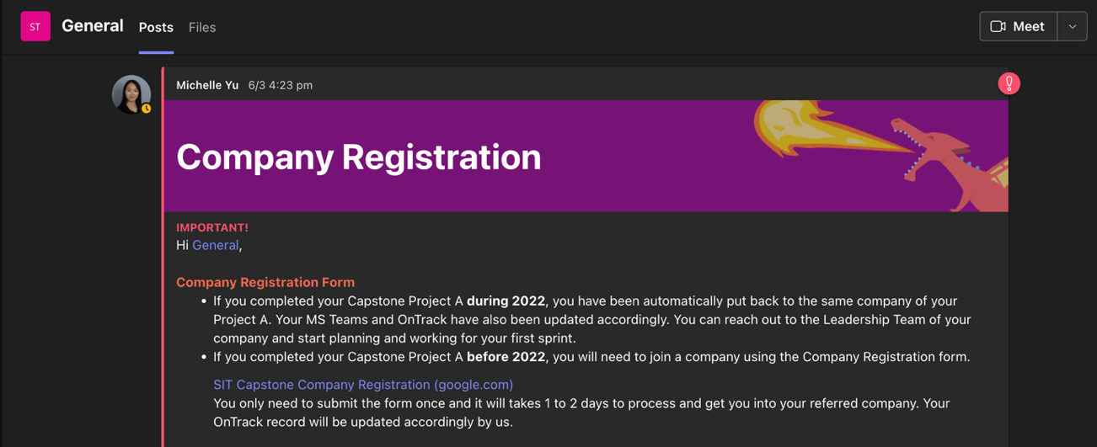

Figure 1: Announcement from the unit chair related to the Company Registration

## Tuesday (7-March-2023)

* Join the Week 1 Lecture Class

## Wednesday (8-March-2023)

* Have a conversation with Chanputhi who is a part of Project Lead team to discuss about the role and position in the Gopher company

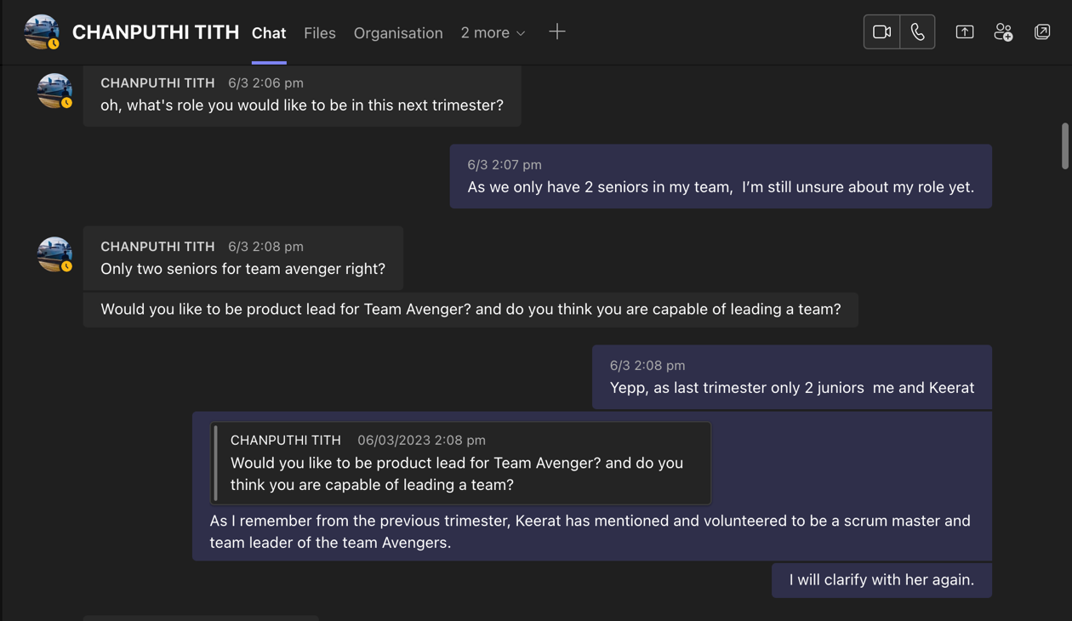

Figure 2: Discuss with Chanputhi about the company progression and relevant information

* Rewatch the first senior meeting catch up Round 1

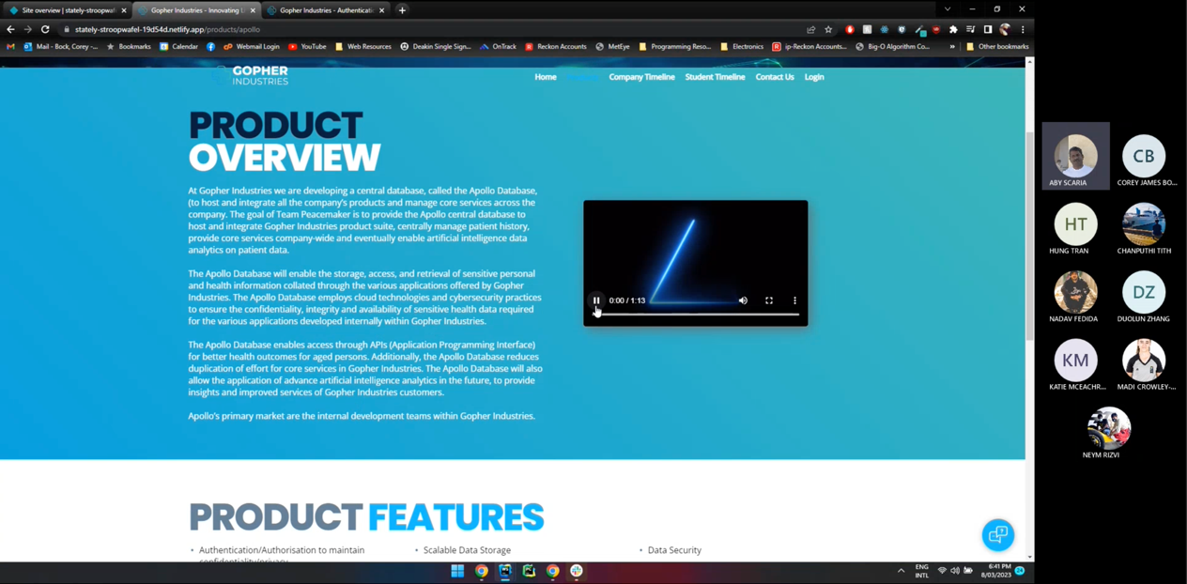

Figure 3: Senior meeting catch up round 1

## Thursday (9-March-2023)

* Rewatch the senior meeting round 2

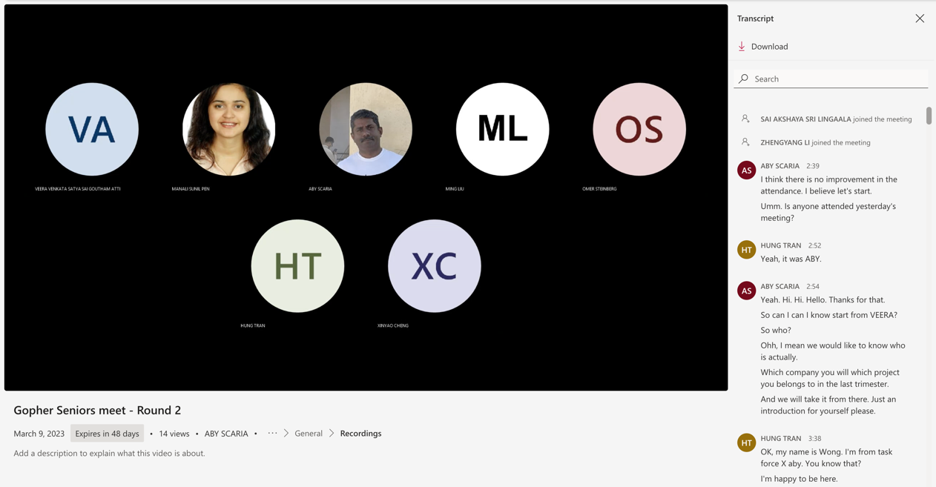

Figure 4: Senior meeting round 2

Week 2

## Tuesday (14-March-2023)

* Complete the Project and Team role selection form for T1

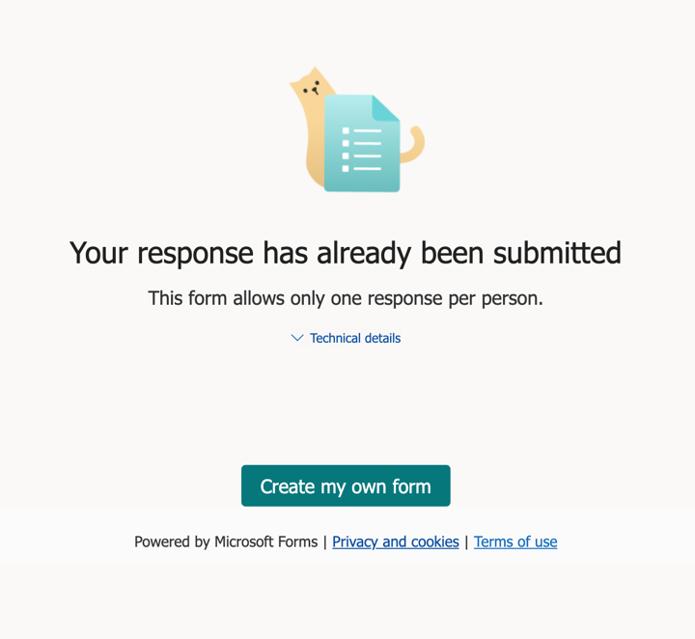

Figure 5: Completed the role selection form

* Join the Week 2 Lecture Class

## Thursday (16-March-2023)

* Join the Gopher Industries meeting with all Seniors and Juniors

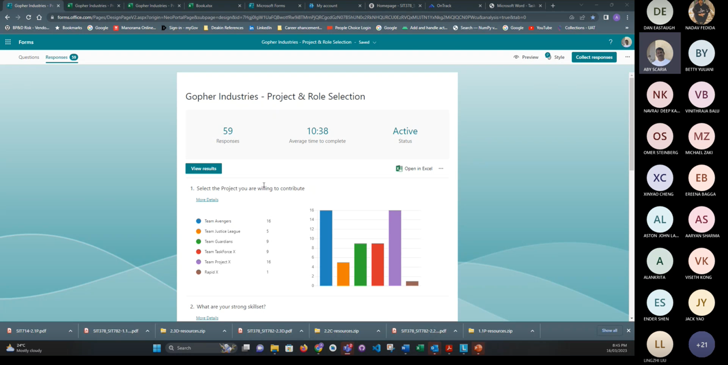

Figure 6: Meeting with all members of Gopher Comapany

## Friday (17-March-2023)

* Complete task 1.1p and 2.1c

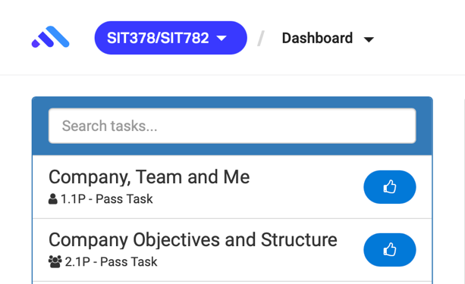

Figure 7: Ontrack Submission

Week 3

## Tuesday (21-March-2023)

* Join the Week 3 Lecture Class

## Wednesday (22-March-2023)

* Join the first Meeting with Team Project X and get to know each other

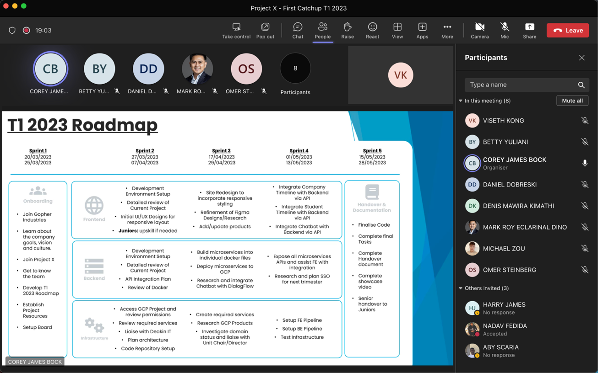

Figure 8: First meeting with Team Project X

* Project X meeting minutes: <https://deakin365.sharepoint.com/sites/GopherIndustries2/Shared%20Documents/Forms/AllItems.aspx?id=%2Fsites%2FGopherIndustries2%2FShared%20Documents%2FProject%20X%20%28Coming%20Soon%29%2FT1%202023%2FMeeting%20Minutes%2F1%2E%20Project%20X%20Meeting%20Minutes%2022%2E03%2E23%20First%20Meeting%2Epdf&parent=%2Fsites%2FGopherIndustries2%2FShared%20Documents%2FProject%20X%20%28Coming%20Soon%29%2FT1%202023%2FMeeting%20Minutes>

## Thursday (23-March-2023)

* Get familiarise with the team environment and review some of the previous document from T3 such as project handover document and video demonstration.

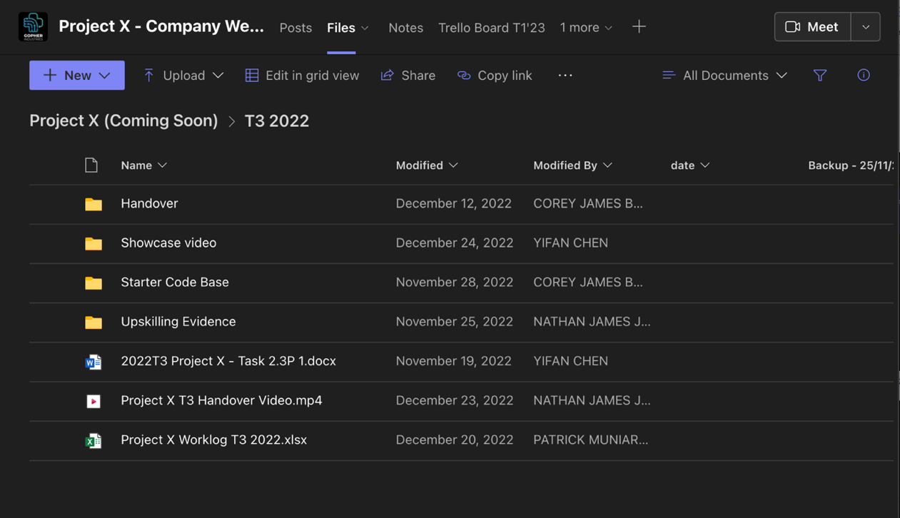

Figure 9: Handover document folder from previous trimester that I need to review

* Set up project folder into local computer, worklog, and daily development note

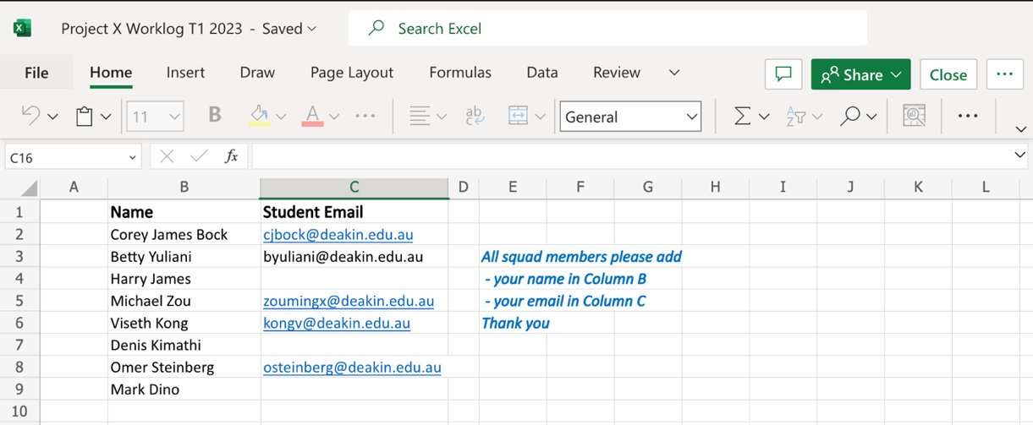

Figure 10: Our team worklog and attendance log for this trimester

* Response to team leader related to my experiences in coding and the role I prefered for this trimester

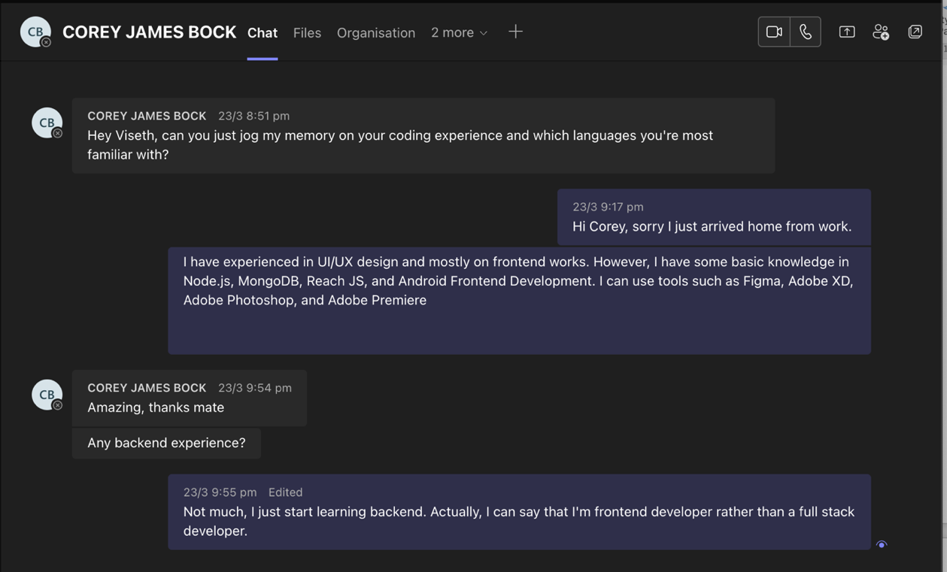

Figure 11: Have some conversation with team leader about the role in the project

## Friday (24-March-2023)

* Document Project Resources Link on GitHub

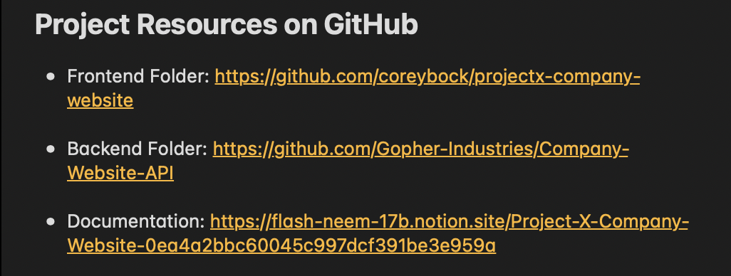

Figure 12: GitHub Resources

* Research and found some essential resources related to the project’s upskilling

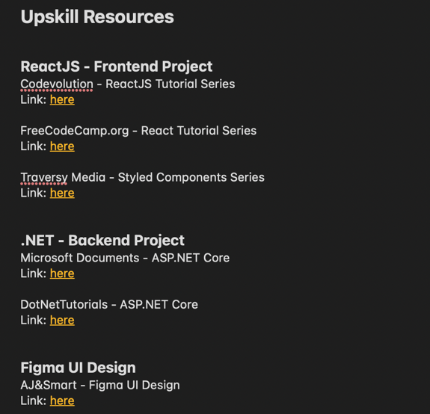

Figure 13: Some resources I found in google which related to my project

Week 4

## Monday (27-March-2023)

* Join Sprint planning Meeting with Team Project X.

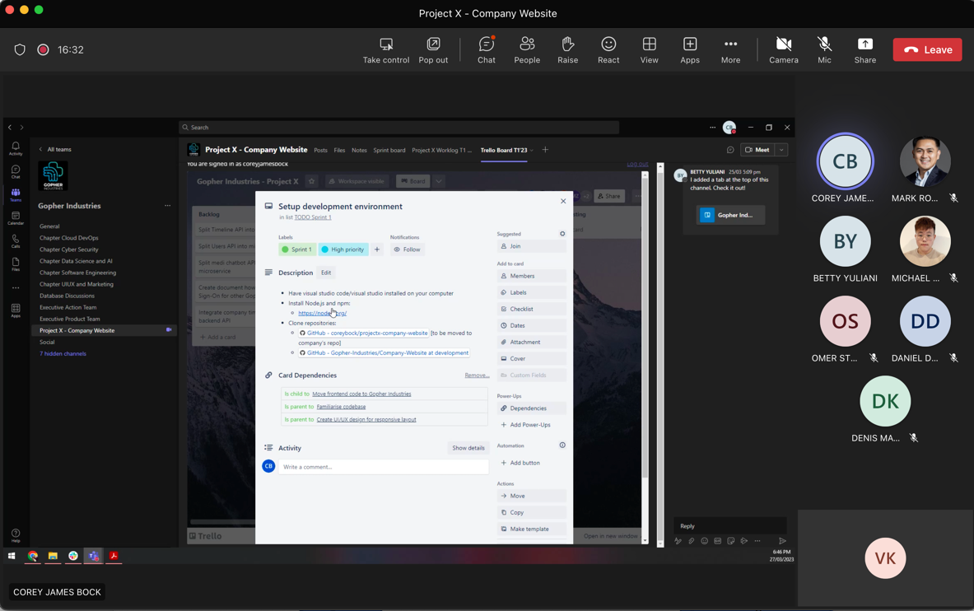

Figure 14: Sprint planning meeting

* Join Project X’s Trello board and read through the assigned task for this week

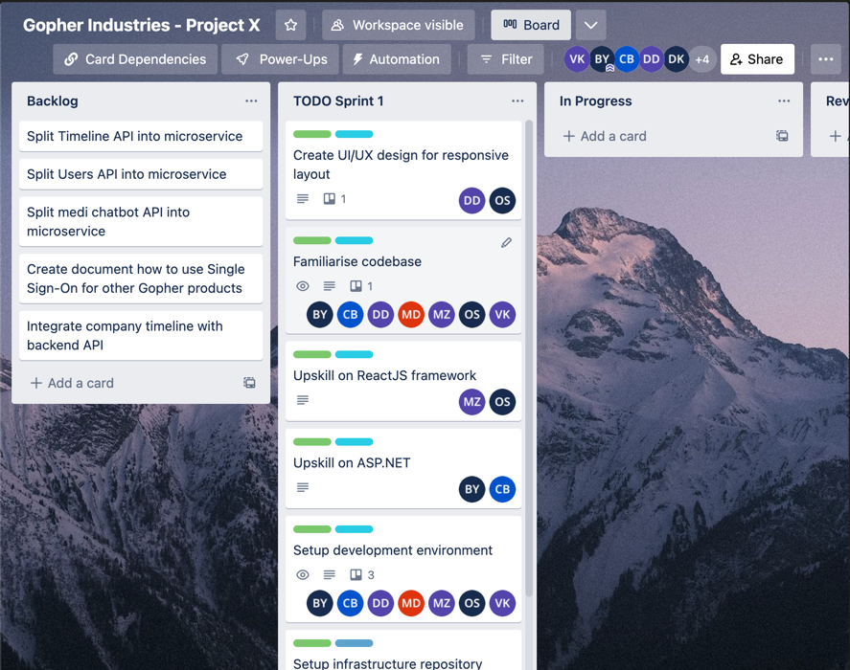

Figure 15: Project X's Trello board

* Project X meeting minutes: <https://deakin365.sharepoint.com/sites/GopherIndustries2/Shared%20Documents/Forms/AllItems.aspx?id=%2Fsites%2FGopherIndustries2%2FShared%20Documents%2FProject%20X%20%28Coming%20Soon%29%2FT1%202023%2FMeeting%20Minutes%2F2%2E%20Project%20X%20Meeting%20Minutes%2027%2E03%2E23%20Sprint%20Planning%20Meeting%2Epdf&parent=%2Fsites%2FGopherIndustries2%2FShared%20Documents%2FProject%20X%20%28Coming%20Soon%29%2FT1%202023%2FMeeting%20Minutes>

## Tuesday (28-March-2023)

* Join the Week 4 Lecture Class
* Setup development environment, cloned the project website and looked through the project code

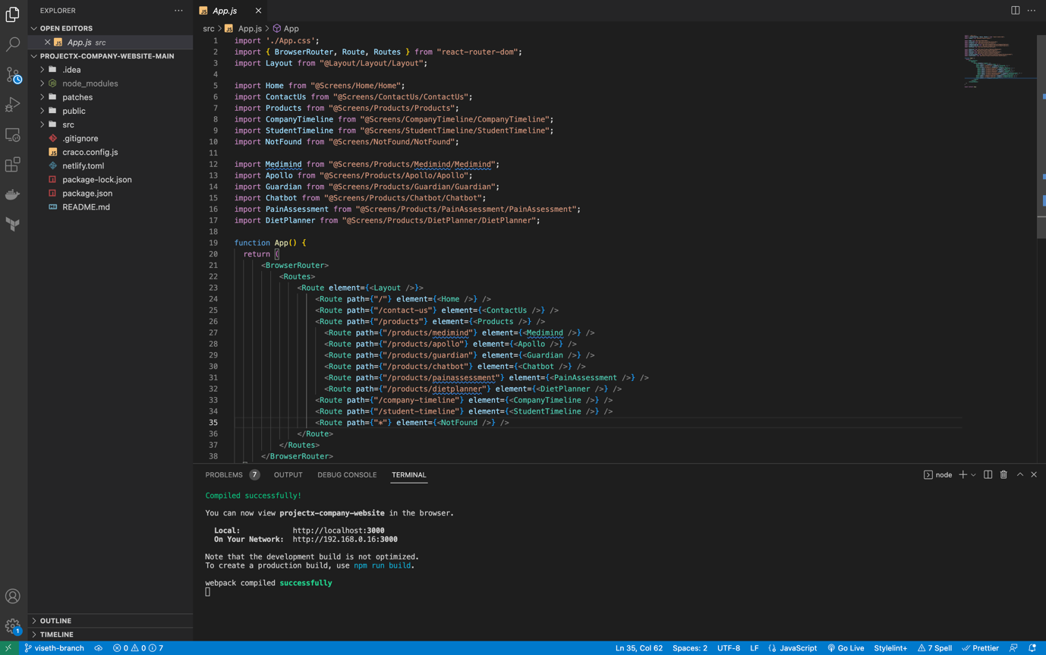

Figure 16: Frontend website code folder

* Run and tested the website on my local computer

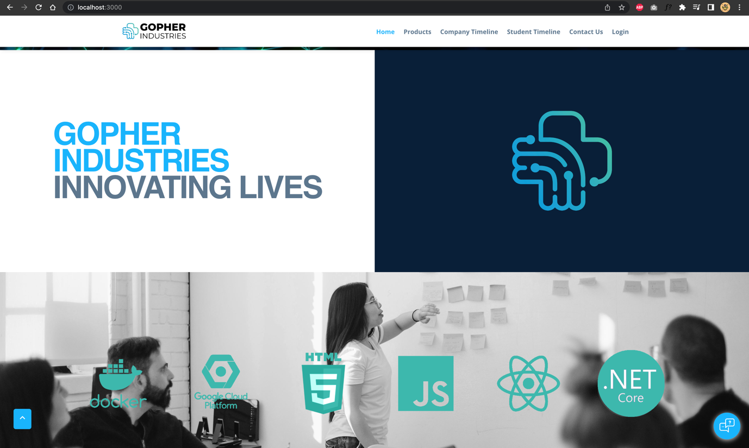

Figure 17: Run the website on my local machine

* Informal Stand-up to provide my progress report:

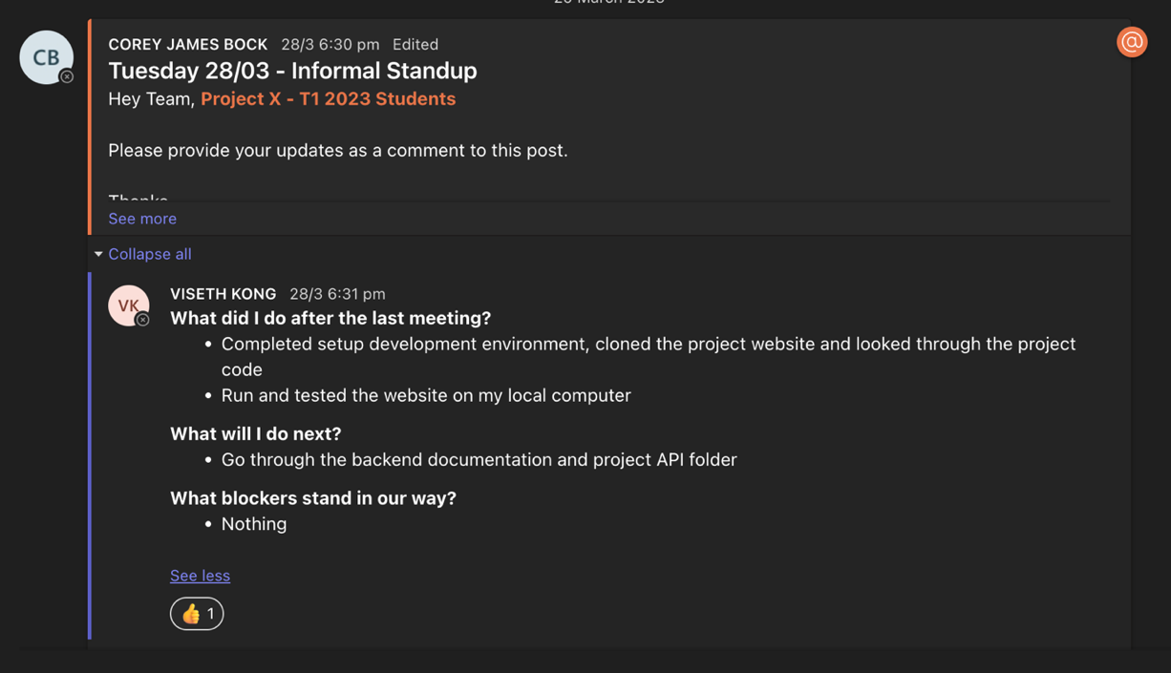

Figure 18: Progress report

## Wednesday (29-March-2023)

* Upskill on React fundamental through YouTube and various website, then start to create a basic website using react

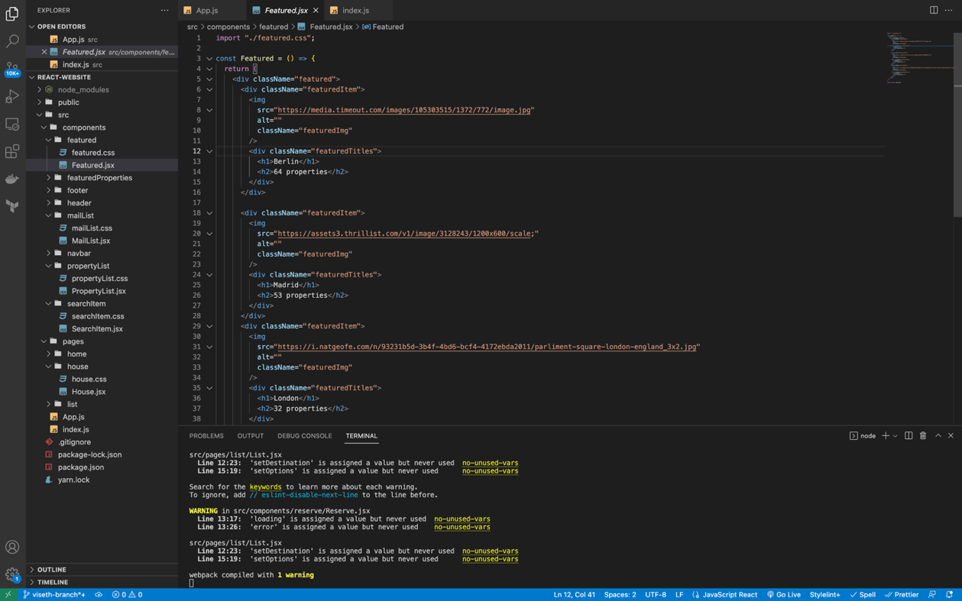

Figure 19: Create a basic React website

* Read through the notion backend and API documentation

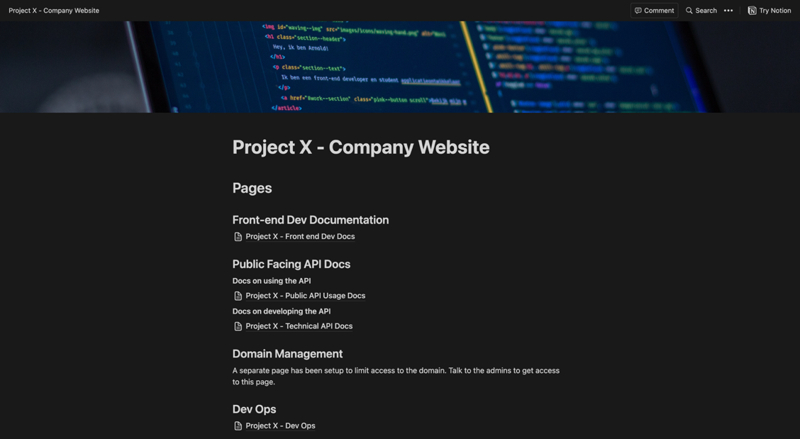

Figure 20: Read through the API documentation provided by previous senior member

* Informal Stand-up to provide my progress report:

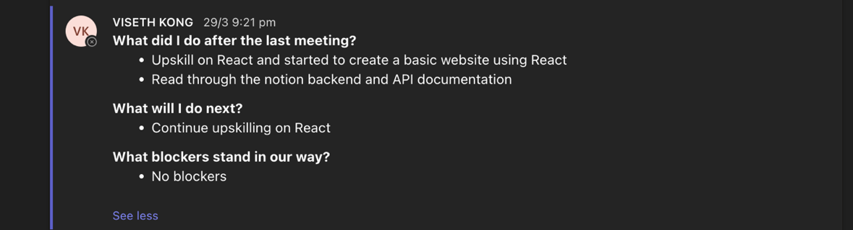

Figure 21: Progress report

## Thursday (30-March-2023)

* Continue upskilling on React and working on my basic React website

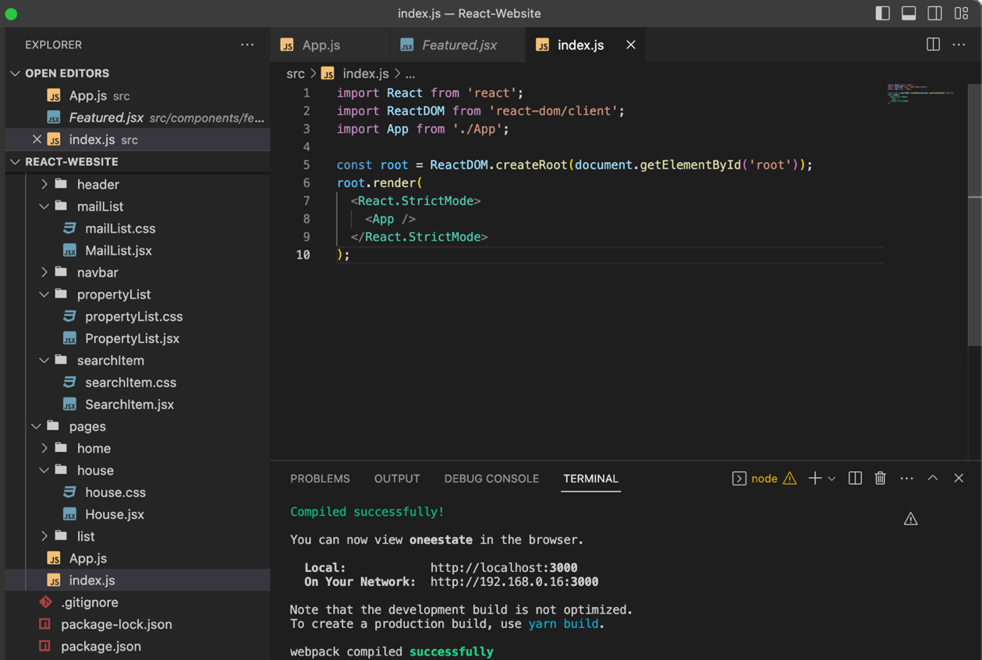

Figure 22: Continue working on React project

* Join Daily Stand-up meeting

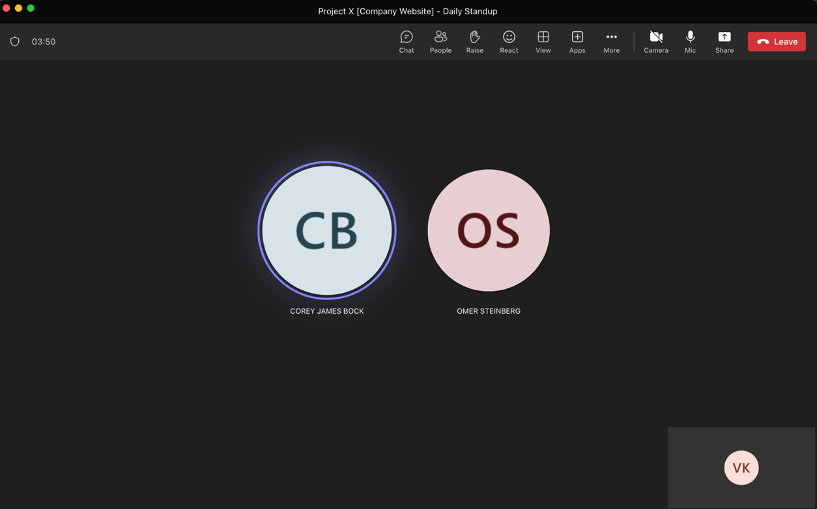

Figure 23: Daily meeting to provide my progession

## Friday (31-March-2023)

* Continue upskilling on React and completed my basic React website <https://github.com/visethkong/SIT7378-SIT782/tree/main/My-Work-And-Contribution/React-Upskilling>



Figure 24: Completed a front-end website using React

* Learn how to use GitHub and Git command to clone, add, commit and push.

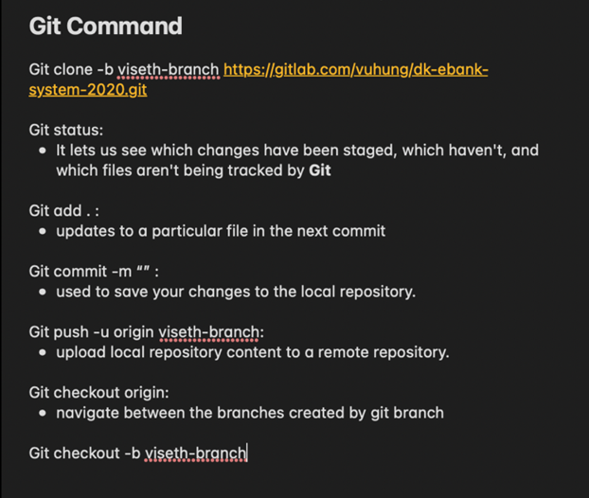

Figure 25: Git Command Notes

Week 5

## Monday (3-April-2023)

* Join Sprint planning Meeting with Team Project X.

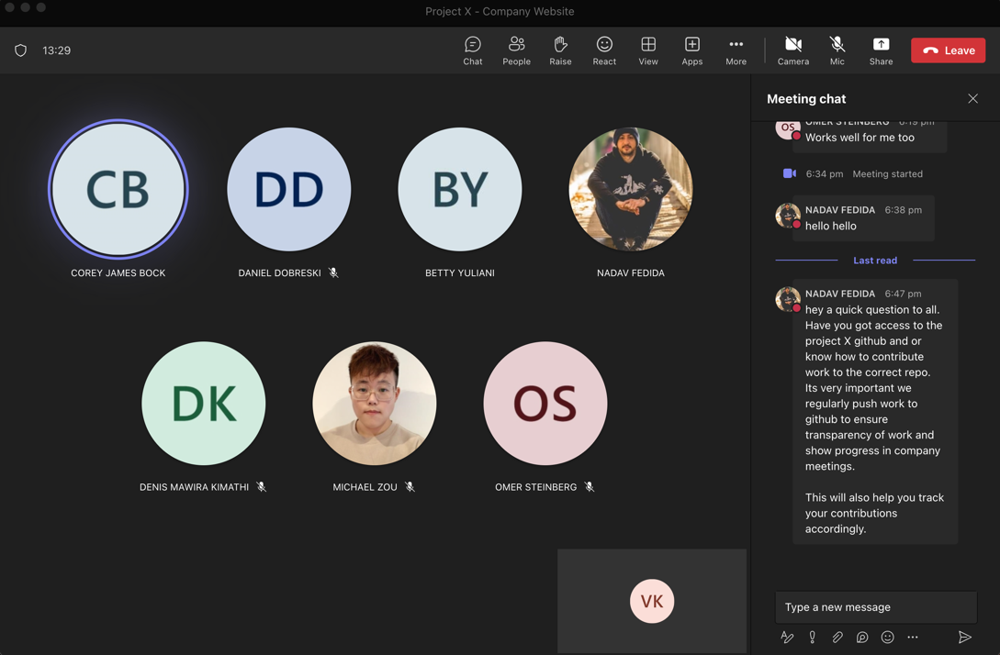

Figure 26: Sprint Planning meeting

## Tuesday (4-April-2023)

* Join the Week 5 Lecture Class
* Continue my upskilling in ReactJS and watch the Styled Components Crash Course

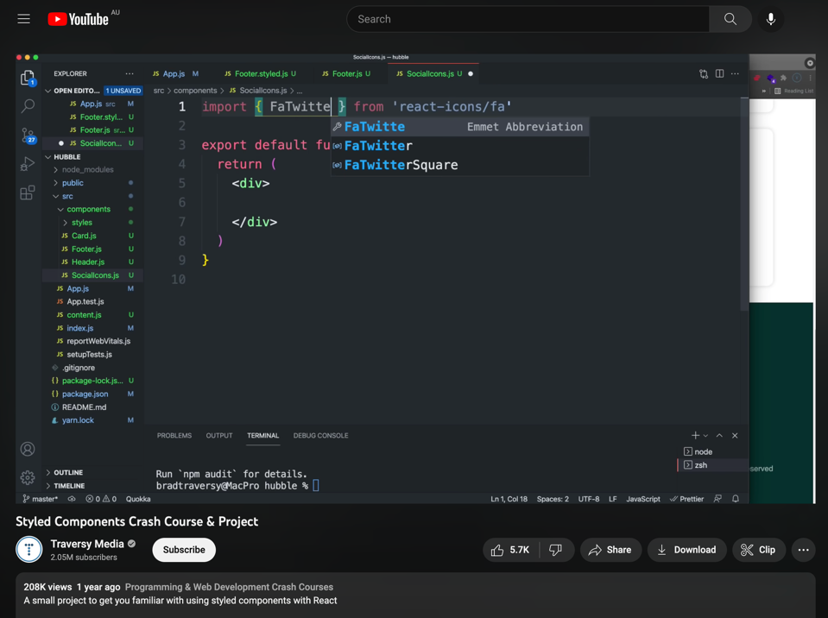

Figure 27: Watch tutorial videos on YouTube

* Informal Stand-up to provide my progress report:

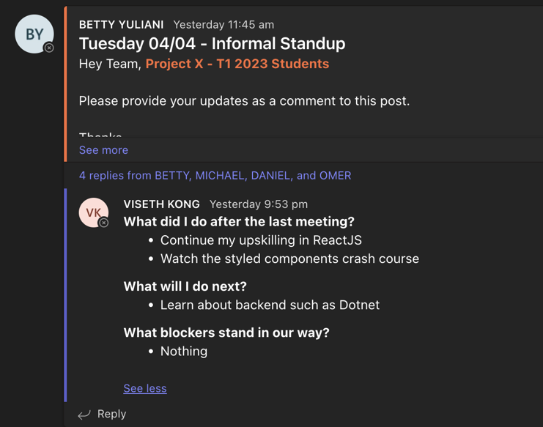

Figure 28: Progress Report

## Wednesday (5-April-2023)

* Backend upskilling and research about Dotnet

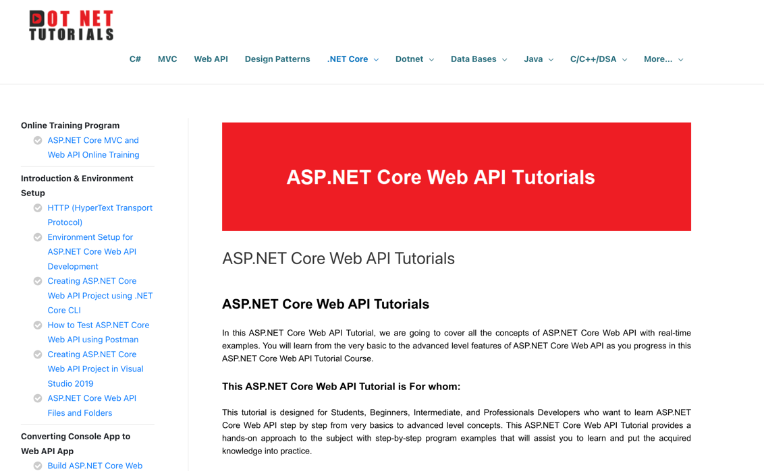

Figure 29: Dotnet Tutorial

* Informal Stand-up to provide my progress report:

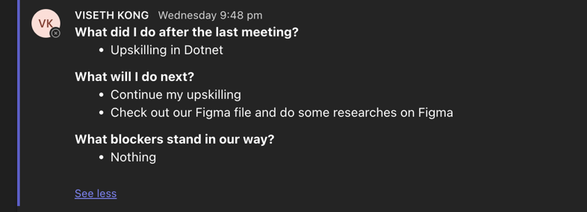

Figure 30: Progress Report

## Thursday (6-April-2023)

* Join Daily Stand-up meeting
* Continue my upskilling in Dotnet
* Check out Project X’s Figma file and do some researches on Figma <https://www.figma.com/file/g5U5ciAPALR6XMQDAbuqSJ/Project-X---T1-2023?t=mzr13sbTNo0yLqc1-0>

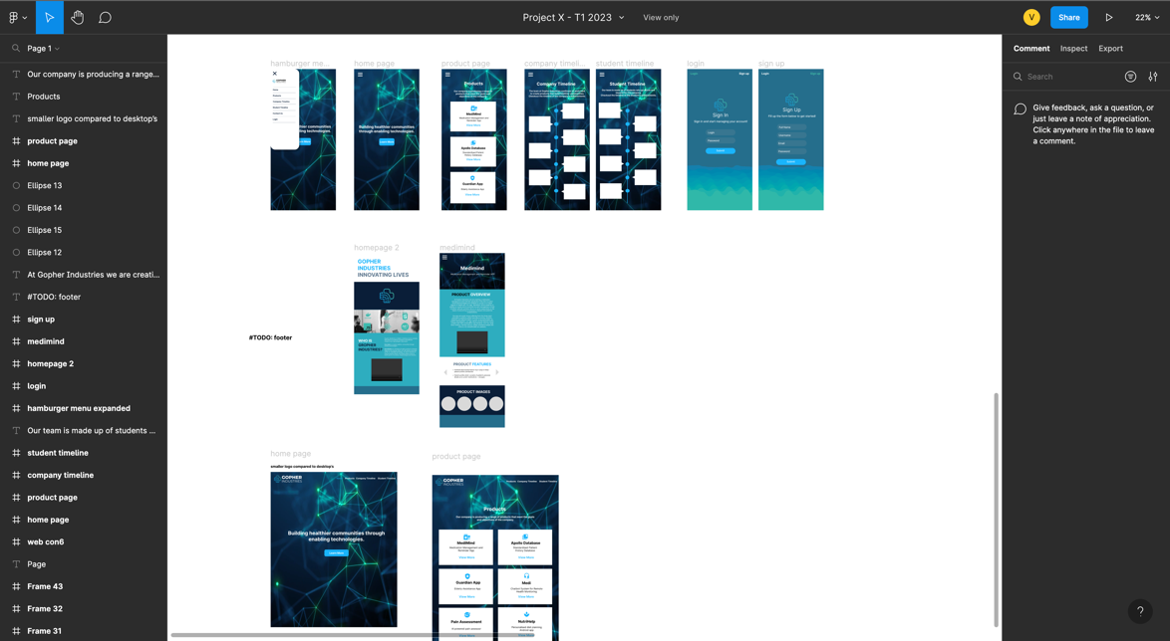

Figure 31: Project X's Figma file

Mid-Break Week

## Tuesday (11-April-2023)

* Informal Stand-up to provide my progress report:

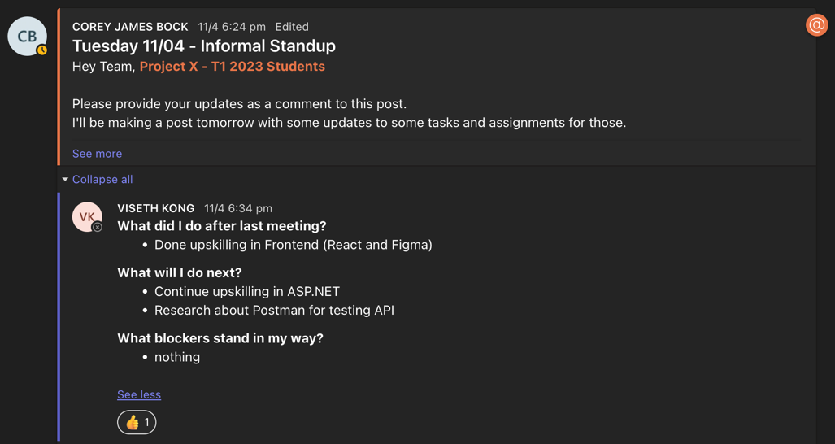

Figure 32: Progress Report

## Wednesday (12-April-2023)

* Research and upskill on Styled-Components Resource:

<https://styled-components.com/docs/basics>

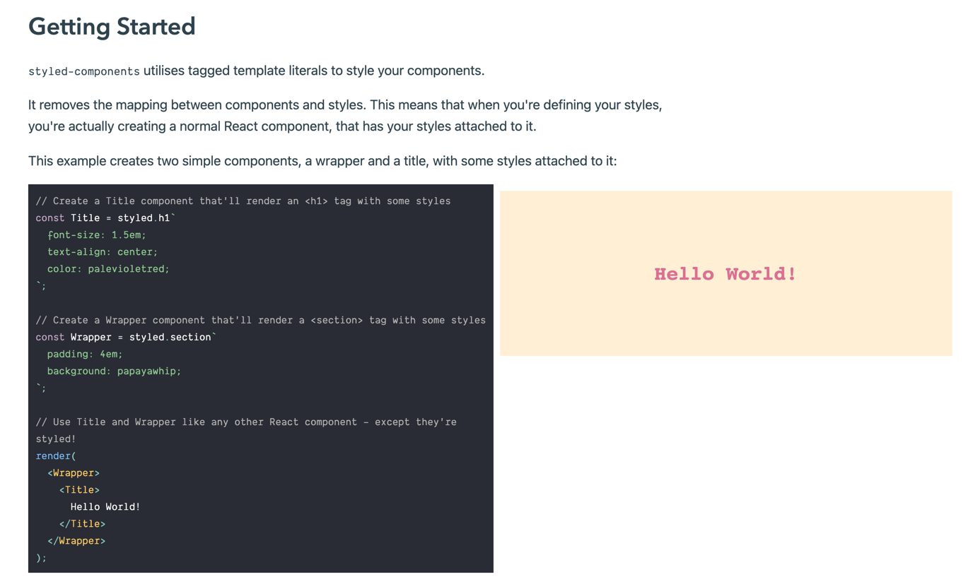

Figure 33: Styled-components Website

<https://jsramblings.com/how-to-use-media-queries-with-styled-components/>

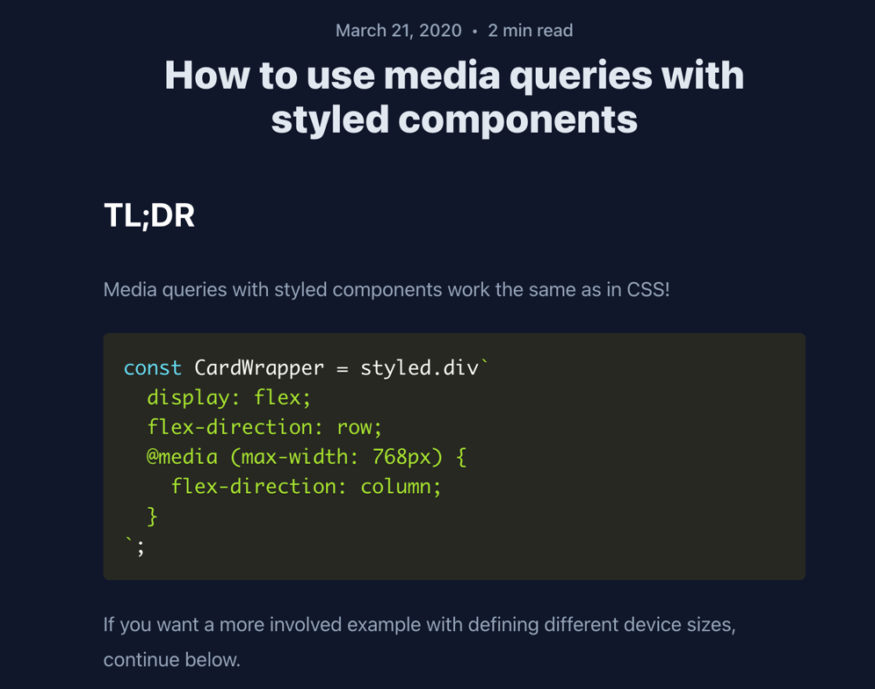

Figure 34: Jsramblings Website

## Thursday (13-April-2023)

* Mid trimester break progress update and update task progress on Trello card
* Watch ASP.NET Core Crash Course:

<https://www.youtube.com/watch?v=BfEjDD8mWYg>

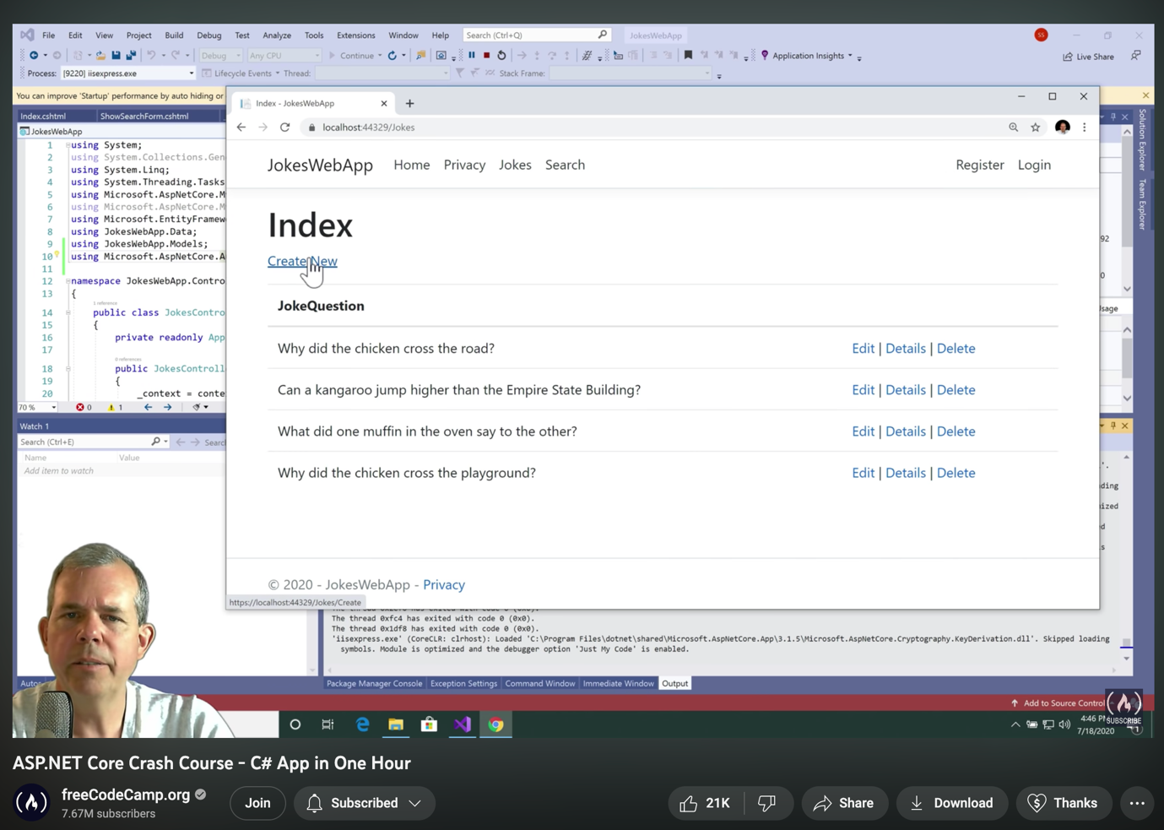

Figure 35: ASP.NET Crash Course from FreeCodeCamp

Week 6

## Monday (17-April-2023)

* Join sprint planning meeting
* Continue research on Styled-Component React

## Tuesday (18-April-2023)

* Join the Week 6 Lecture Class
* Try to run the ProjectX WebAPI and follow Betty’s instruction

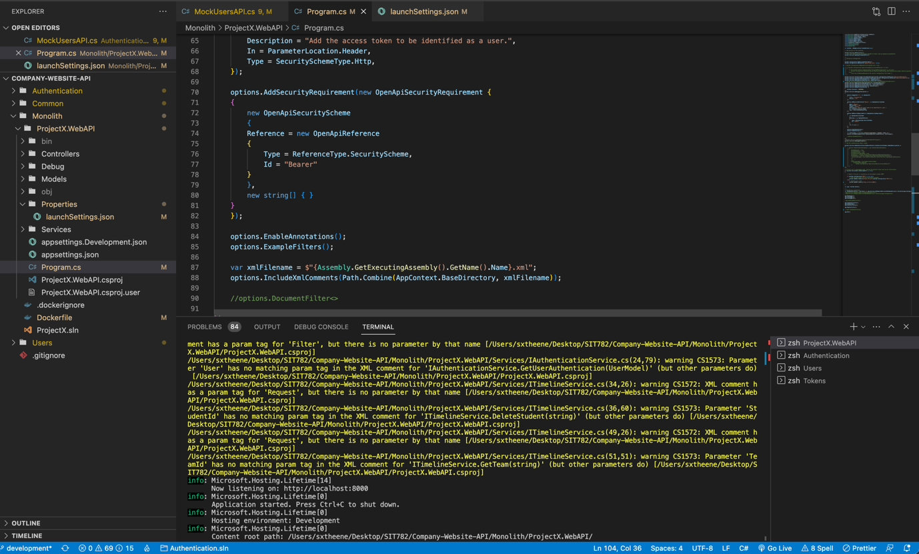

Figure 36: Company Web API codebase

* Research on how to downgrade Dotnet version to work with the Web API codebase:

<https://www.youtube.com/watch?v=tkVODgVtH5g>

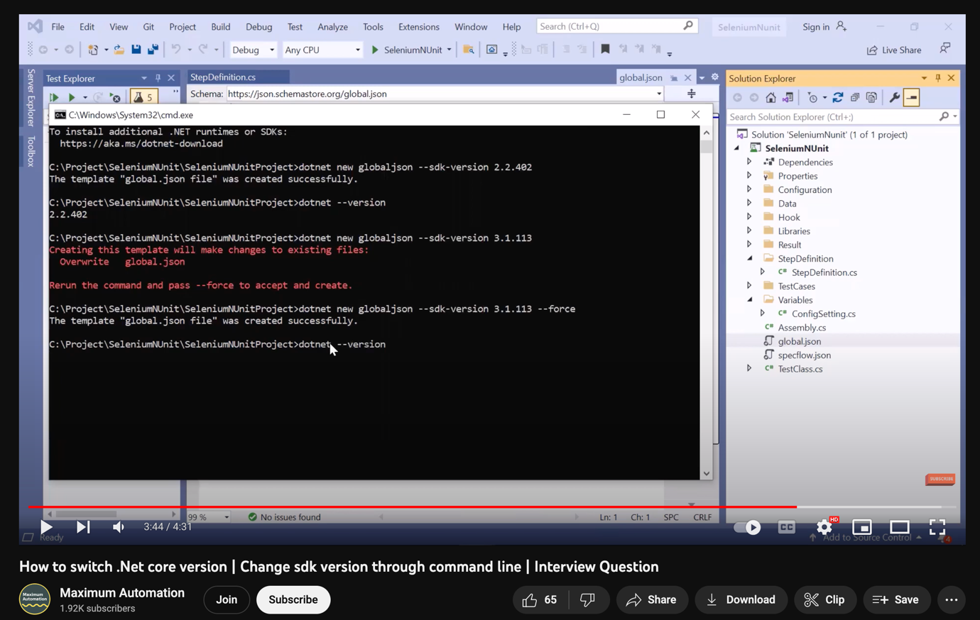

Figure 37: Downgrade Dotnet Version Tutorial

* Read through the Backend API documentation on Notion:

<https://flash-neem-17b.notion.site/Project-X-Company-Website-0ea4a2bbc60045c997dcf391be3e959a>

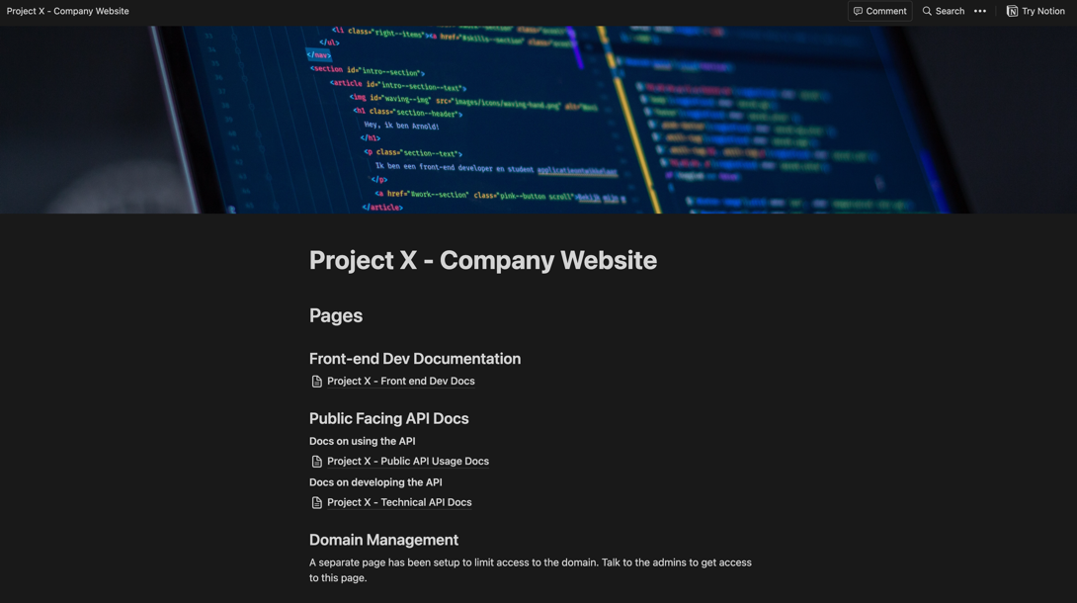

Figure 138: Project X Documentation

* Have a conversation with Betty about the code running issues of Web API

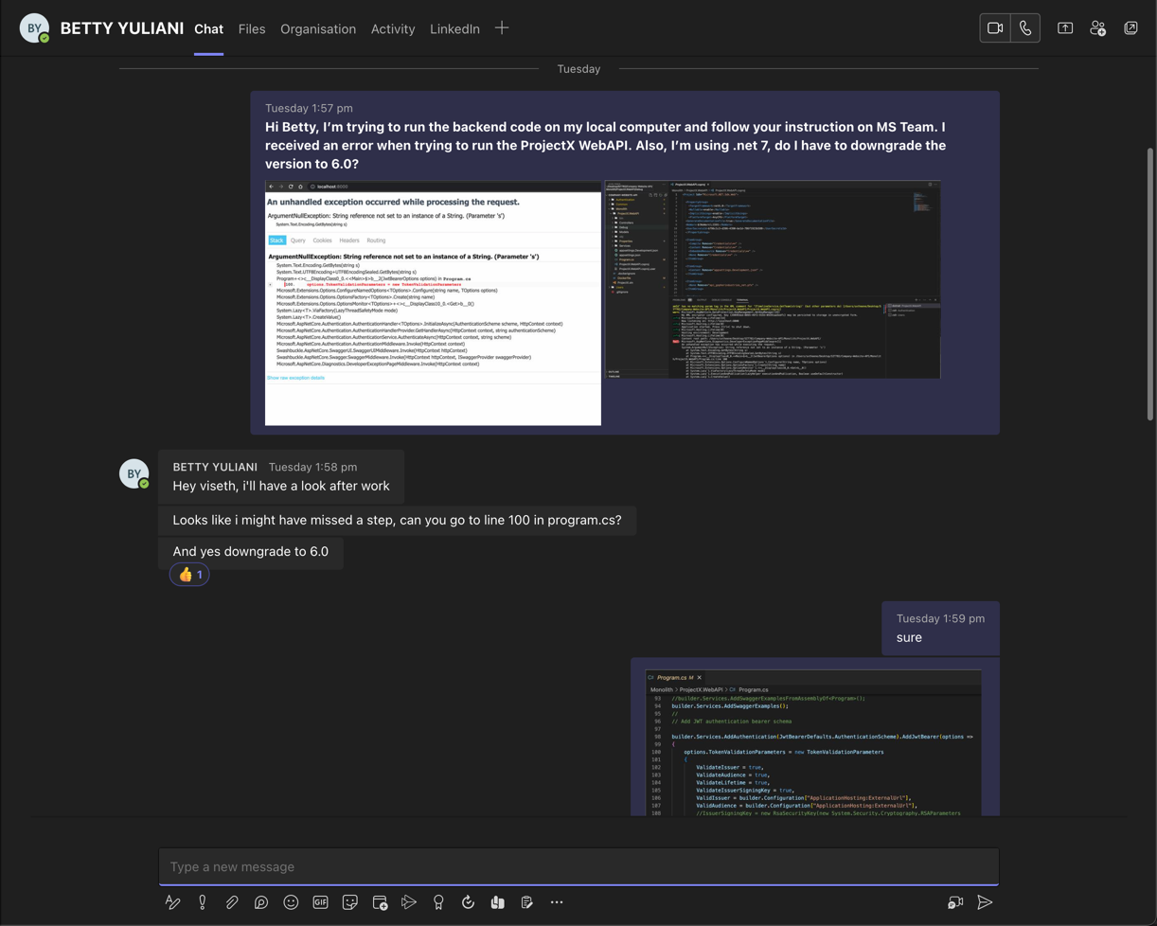

Figure 39: Chatting with Betty regarding the issues

* Informal Stand-up to provide my progress report:

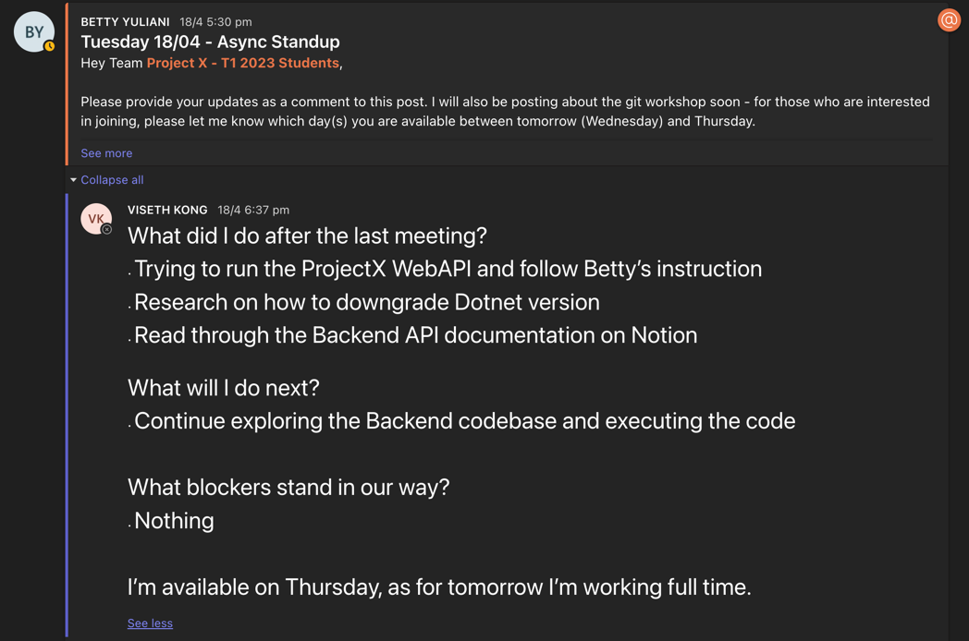

Figure 40: Progress Report

## Wednesday (19-April-2023)

* Task assigned to work on responsiveness to product page

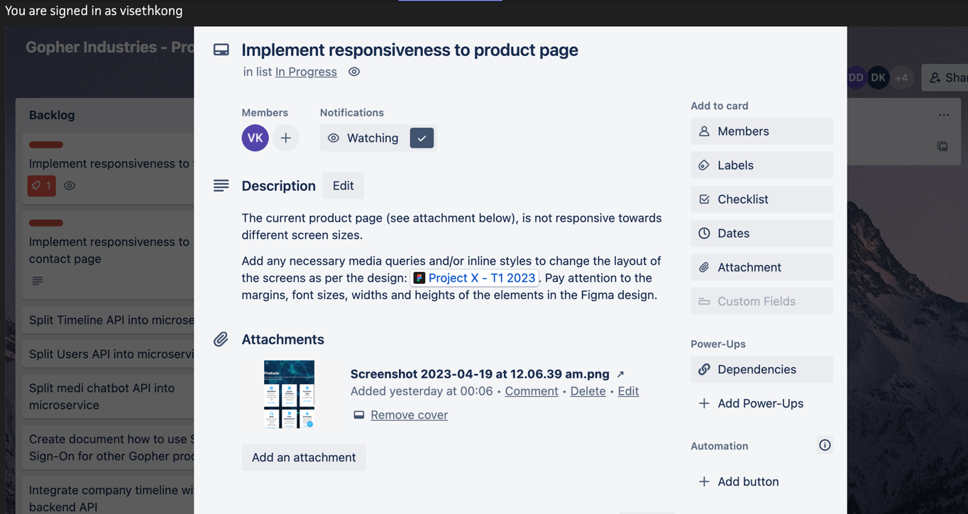

Figure 141: Task on Trello board

## Thursday (20-April-2023)

* Research on CSS Media query and device screen size for the Tablet and mobile phones
* Explore the Figma file to note down all the size of elements for each design such as margins, font sizes, widths and heights
* Join Daily Stand-up meeting

## Saturday (22-April-2023)

* Research on Responsive CSS components (container, grid, column-gap, video screen size):

<https://developer.mozilla.org/en-US/docs/Web/CSS/column-gap>

<https://css-tricks.com/almanac/properties/g/grid-template-columns/>

<https://udn.realityripple.com/docs/Web/CSS/column-gap>

<https://www.w3schools.com/cssref/pr_grid-column-gap.php>

<https://stackoverflow.com/questions/36949747/make-video-fit-100-with-any-screen-resolution>

<https://www.sitepoint.com/community/t/change-to-container-fluid-on-mobile-devices/333058/4>

* Develop and implement responsiveness to Product page (For Tablet)

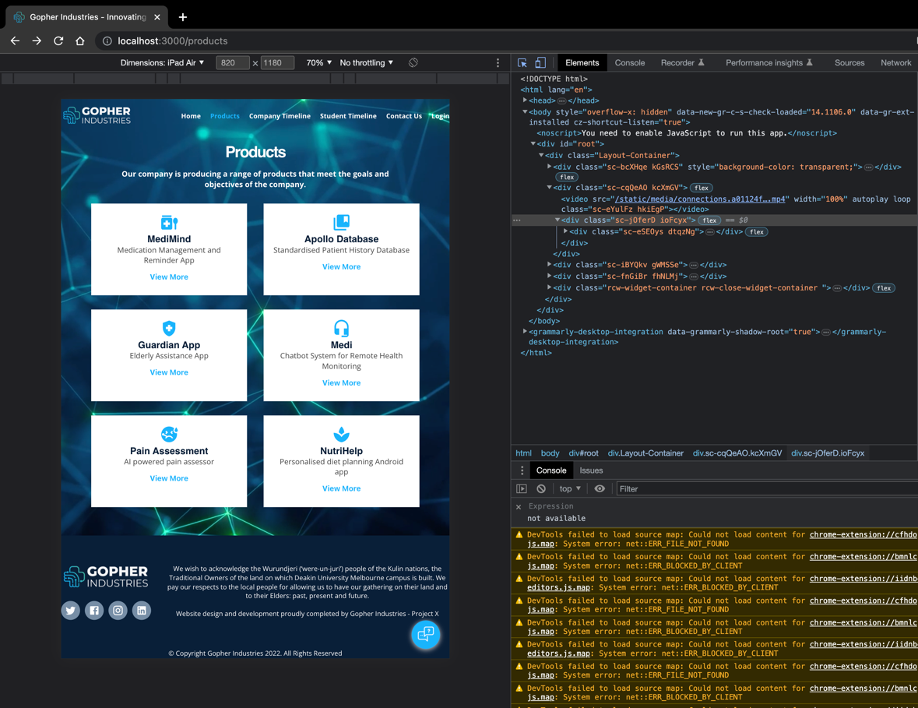

Figure 42: Product Page display in Tablet screen size

## Sunday (23-April-2023)

* Continue working on develop responsiveness to Product page (For Mobile)

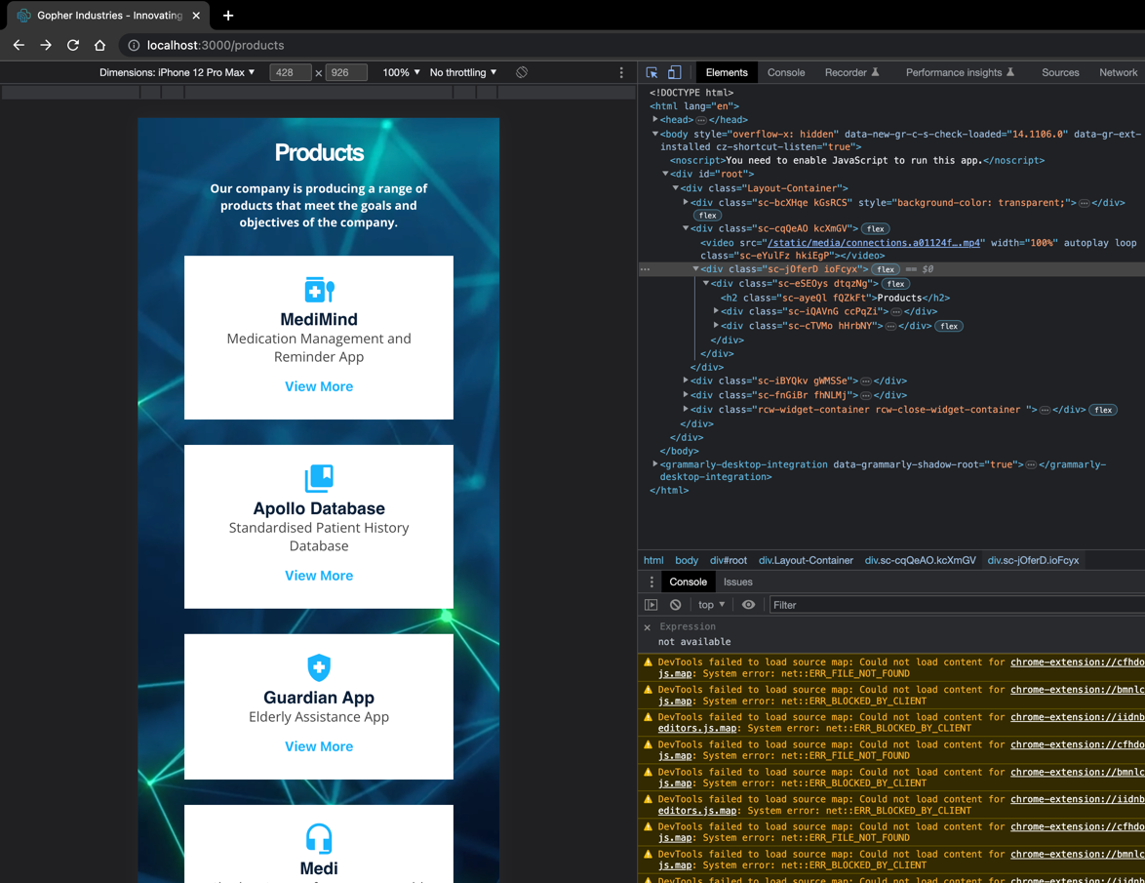

Figure 43: Product page display in Mobile screen size

* Watch the Git Workshop video provided by Betty

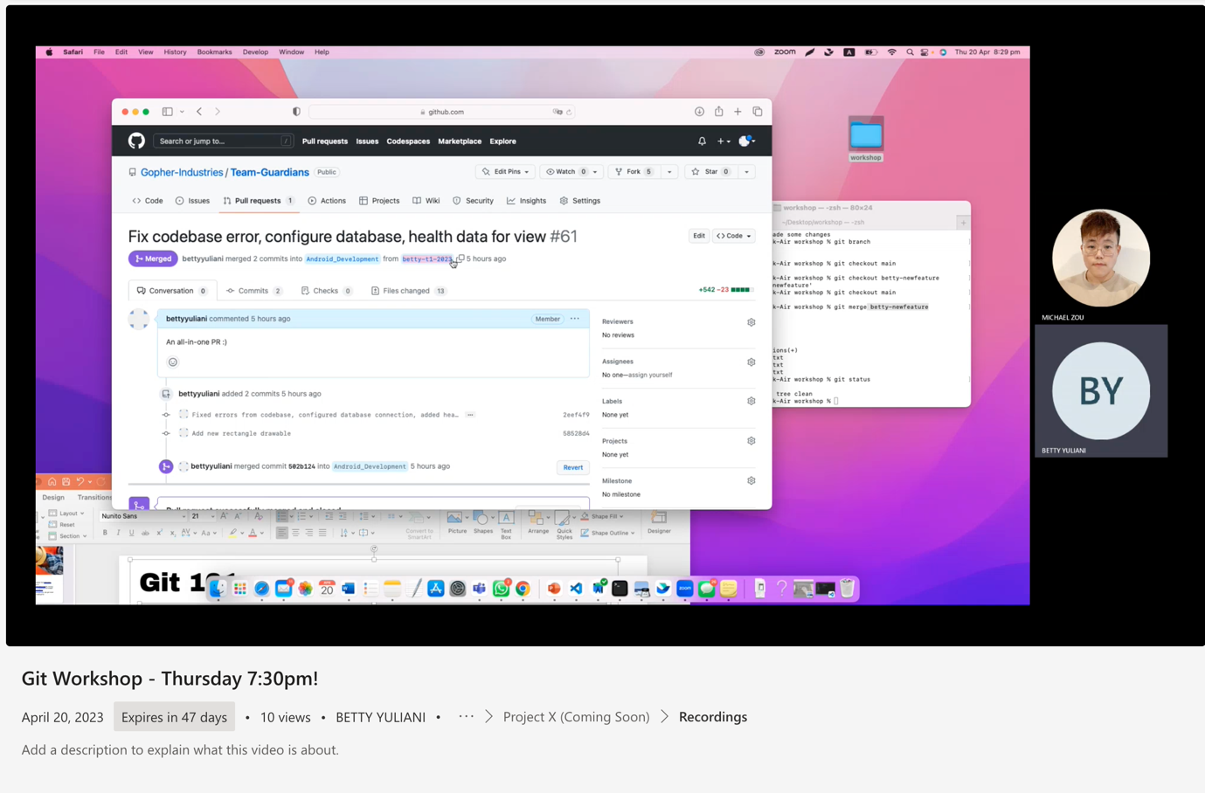

Figure 44: GitHub Workshop provided by Betty

* Upskill on Git Workflow (Git 101) and git Configuration by generate SSH key and add it to GitHub

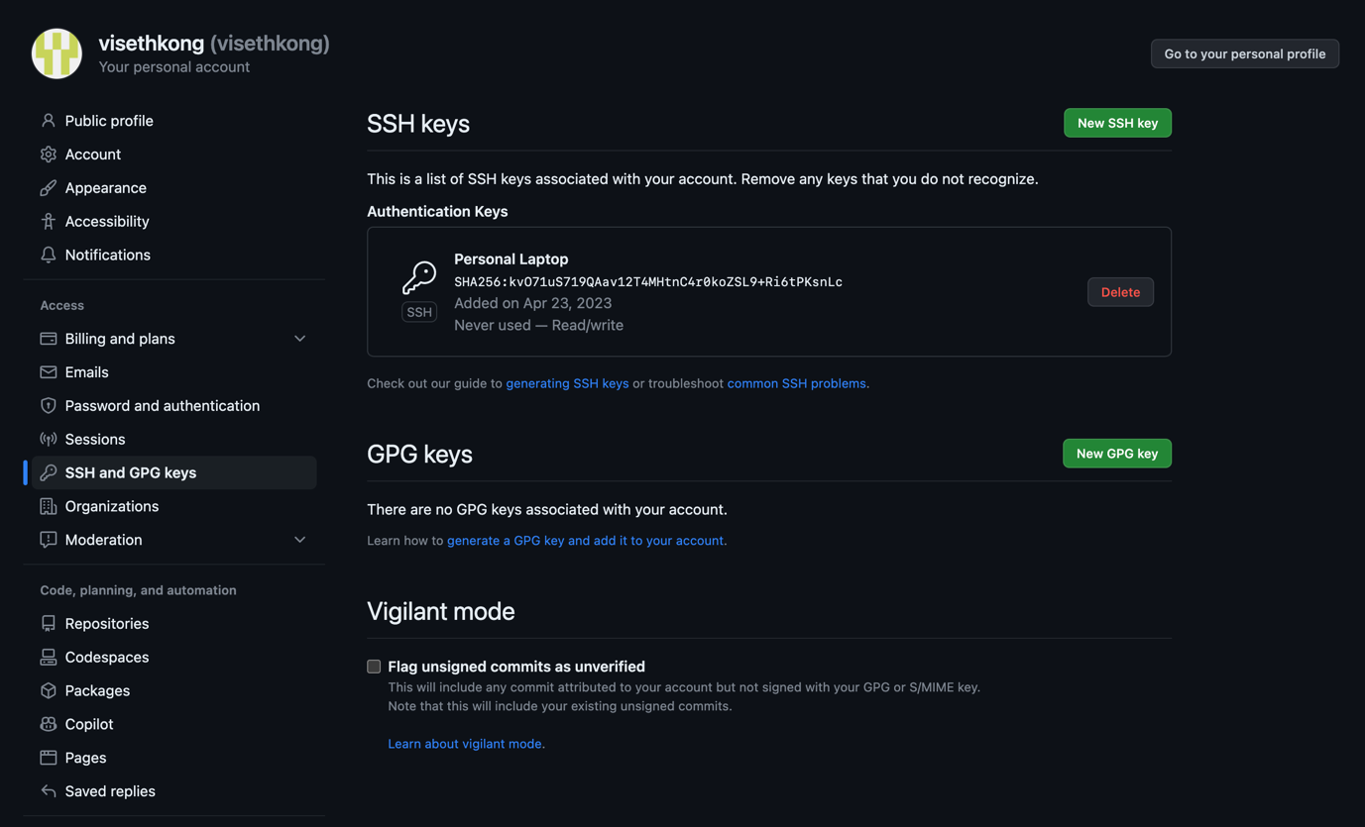

Figure 45: Git configuration

Week 7

## Monday (24-April-2023)

* Join sprint planning meeting

## Tuesday (25-April-2023)

* Join the Week 7 Lecture Class
* Task assigned to work on responsiveness to Footer

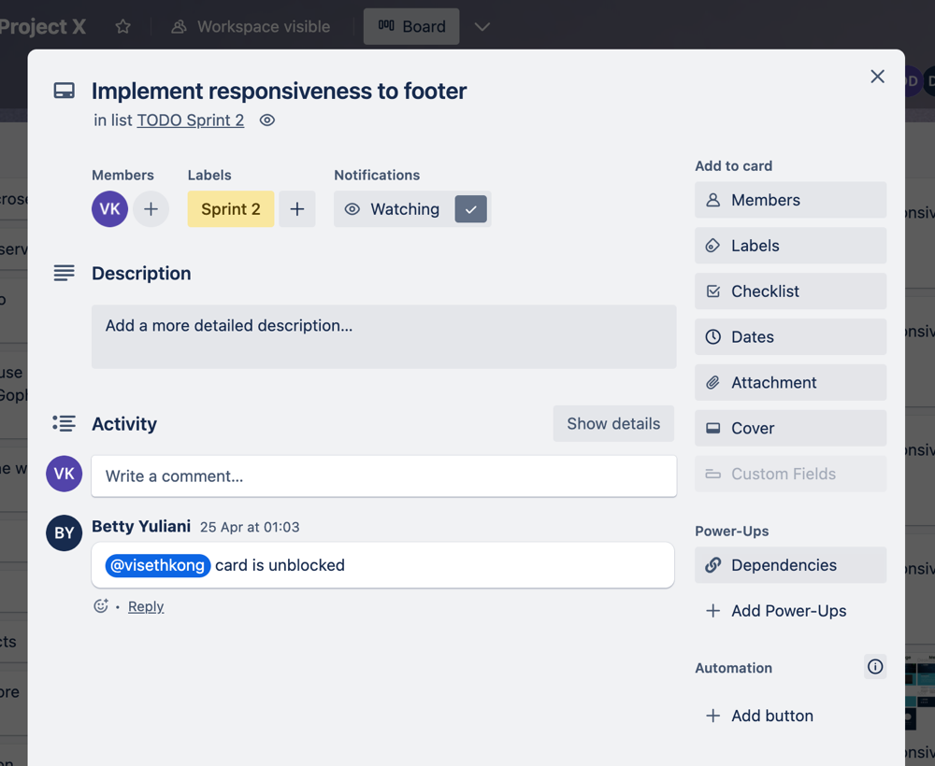

Figure 46: Task on Trello Board

* Develop and implement responsiveness to Footer (For Tablet)

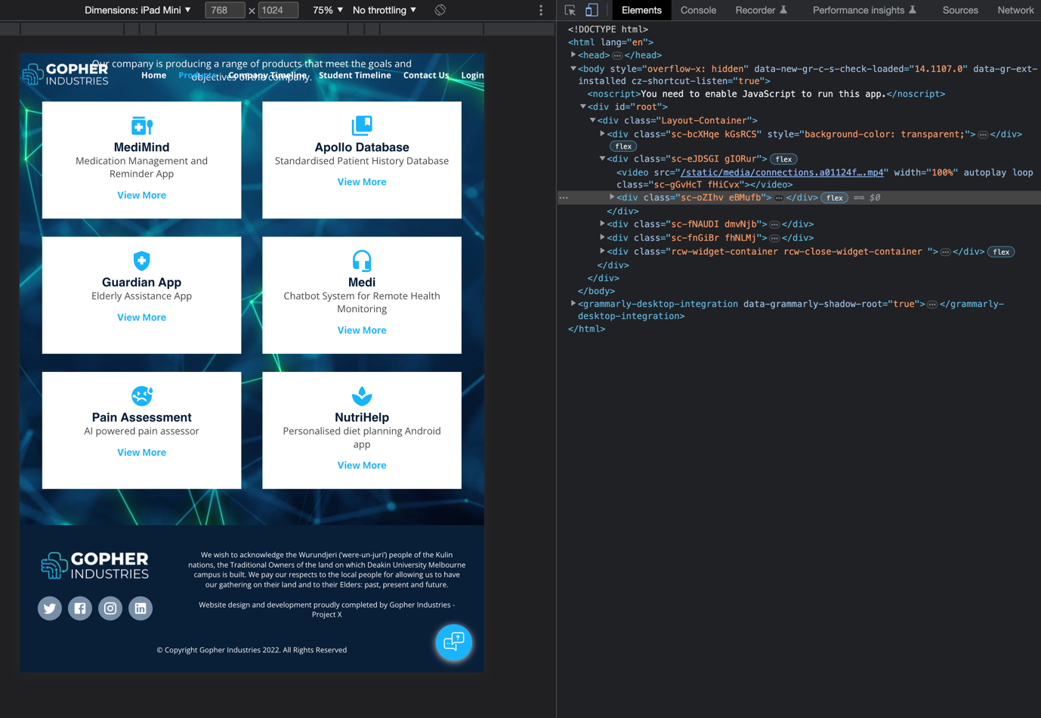

Figure 47: Footer Display in Tablet screen size

## Wednesday (26-April-2023)

* Develop and implement responsiveness to Footer (For Mobile)

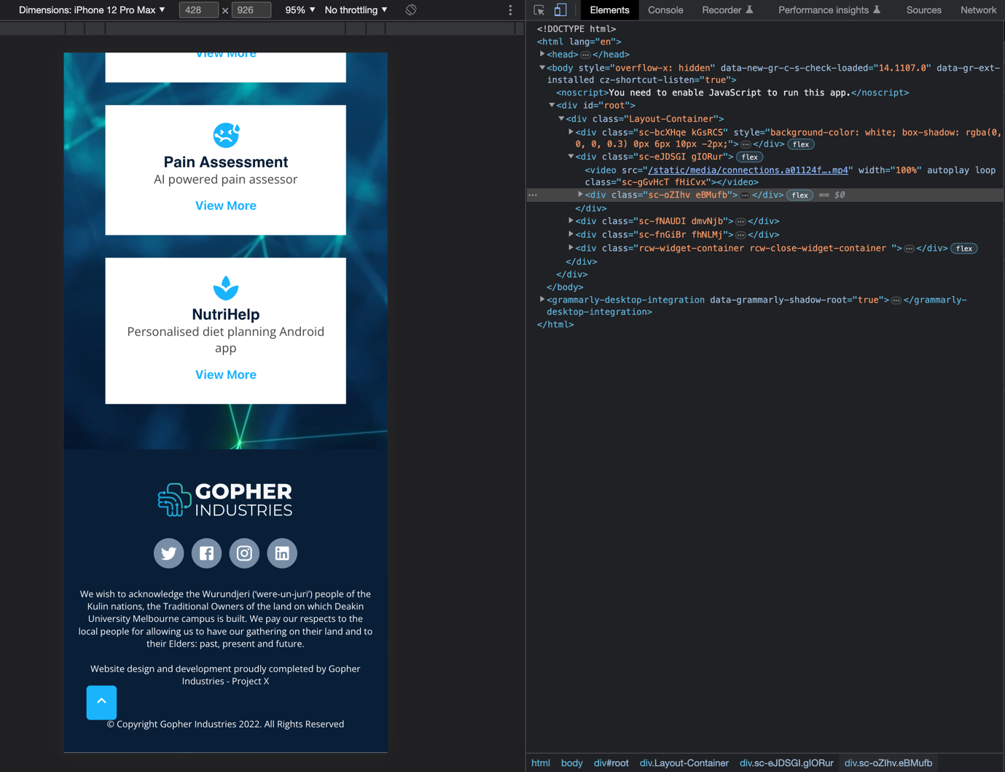

Figure 48: Footer display in Mobile screen size

## Thursday (27-April-2023)

* Fix and clean up the CSS code for Product page and Footer
* Join Daily Stand-up meeting

## Friday (28-April-2023)

* Git troubleshooting and research on how to create pull request on GitHub:

<https://www.digitalocean.com/community/tutorials/how-to-create-a-pull-request-on-github>

<https://docs.github.com/en/pull-requests/collaborating-with-pull-requests/proposing-changes-to-your-work-with-pull-requests/creating-a-pull-request-from-a-fork>

## Saturday (29-April-2023)

* Have a conversation with Corey about the Git command issues

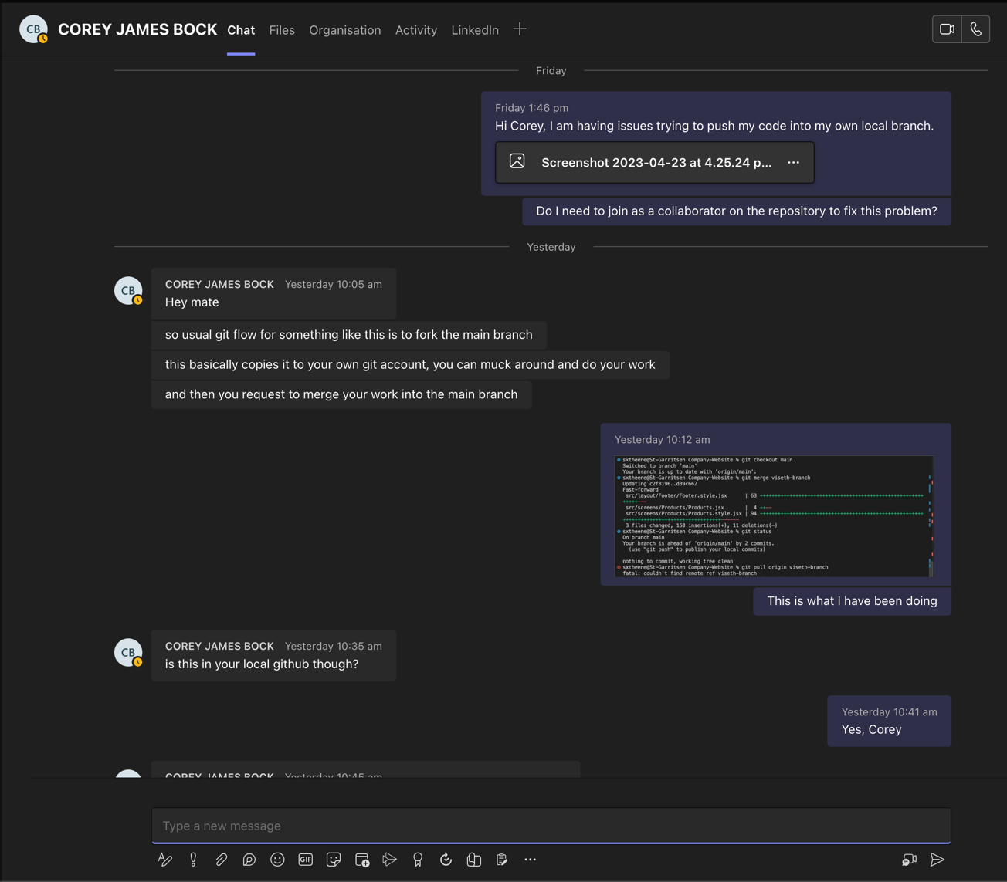

Figure 49: Talk with Corey regarding to the Git issues

* Successfully make a pull request to GitHub of Company Website

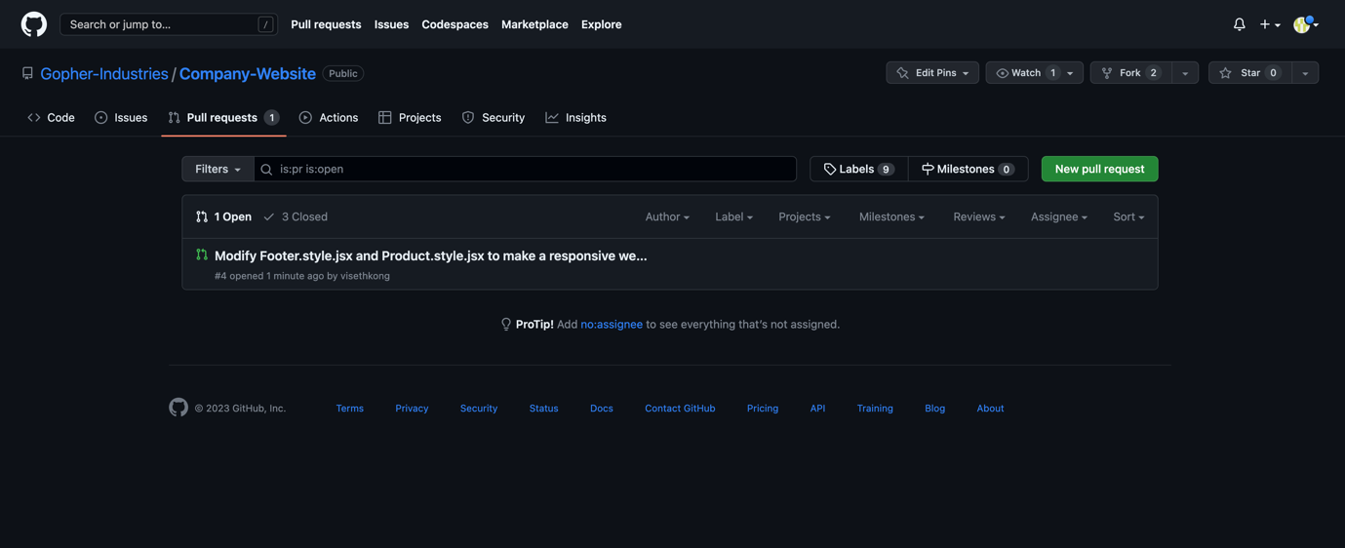

Figure 50: Make a pull request for Team member to review